Program for Marine Ranching Visit

RO Korea
14-18 October 2019

Day 1: 14 Oct (Monday) Arrival of the participants to Jeju island
Day 2: 15 Oct (Tuesday)
09:00~10:00 | From hotel to the site
10:00~10:40 | Site view of Jeju Marine Ranch  Introducer: Jong-ryul KIM, FIRA
10:40~11:20 | Site view of Jeju Marine Forest  Introducer: En-kyu HAN, FIRA
11:20~12:00 | Site view of artificial reef construction site  Introducer: Jong-ryul KIM, FIRA  Construction site for artificial reefs, which are used as a major item for marine resources creation projects (marine forest, marine ranch, etc.) carried out in Jeju. Various types of artificial reefs, including metal and concrete, are being constructed. Large-sized artificial reefs are transported by vessel because they cannot be transported by car, and are being manufactured at ports for easy shipment to vessels.  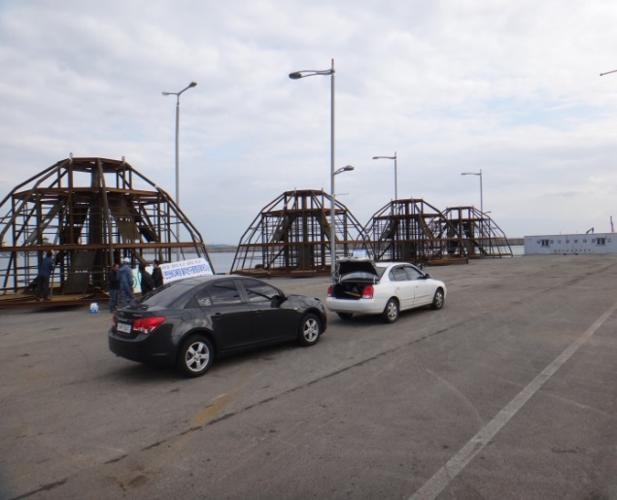
 | Lunch
13:30~14:30 | Site view of Jeju marine ranch experience center  Introducer: Jong-ryul KIM En-kyu HAN, FIRA  Jeju marine ranch experience center is a two story building with ocean experience center and convenience facilities for divers (including accommodation)  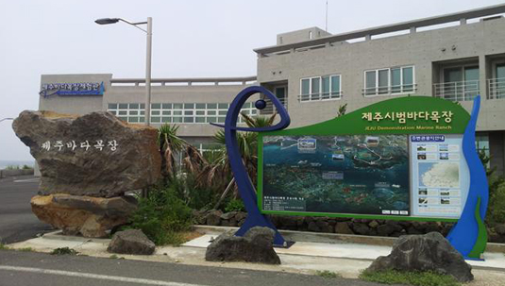
14:30~18:30 | Diving program in Jeju marine ranch or Visit Jeju Aquarium  ※According to weather conditions  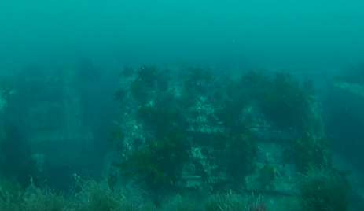  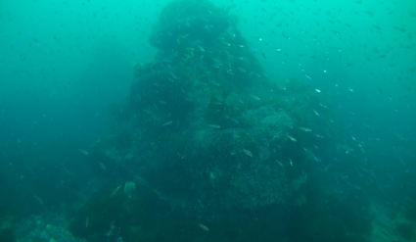
18:30 | Dinner
Day 3: 16 Oct (Wednesday)
09:00~10:00 | From hotel to the site
10:00-11:00 | Fisheries Resources Enhancement Center of NIFS  Introducer: Jong-ryul KIM, En-kyu HAN, FIRA  National Institute for fishery resource management near Jeju Island and research in changes of marine ecosystem  Major research species: Flatfish, Bluefin tuna, sawedged perch etc  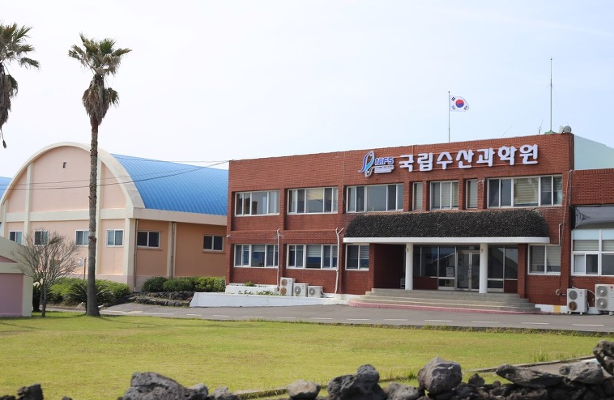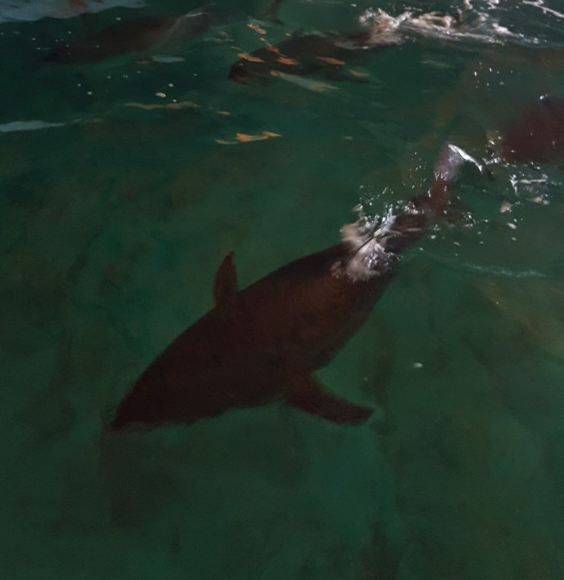
11:00-12:00 | Move to Jeju International Airport
12:00-13:00 | Lunch (near the airport)
13:40-14:45 | From Jeju to Gunsan (flight)
14:45-15:45 | From Gunsan airport to hotel
15:45-18:00 | Break
18:00 | Dinner
Day 4: 17 Oct (Thursday)
09:00~09:30 | From the Hotel to FIRA West Sea branch
09:30~10:00 | Presentation: Introduction to west sea marine ranch in RO Korea  Presenter: Sang-ho BAEK, FIRA
10:00~12:00 | To artificial reef construction site
12:00~13:00 | Lunch
13:00-14:00 | Site view of artificial reef construction site  Introducer: Sang-ho BAEK, FIRA  Construction site for artificial reefs that are used in the West Sea marine ranch and marine forest projects. Located near ports for easy shipment to vessels.  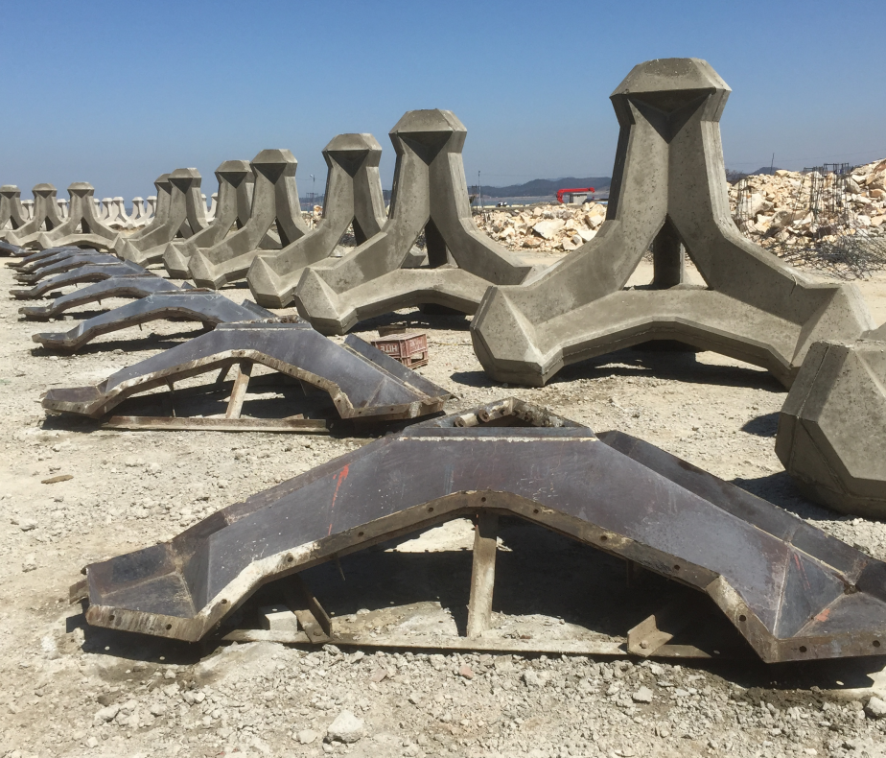
14:00-17:00 | Fishing program site in west sea marine ranch  Considering the characteristics of the West Sea where the tidal range is big, a floating fishing area surrounded by a brim has been constructed. Due to the effect of the marine ranch, various kinds of fish, such as rockfish, are caught even in remote waters.  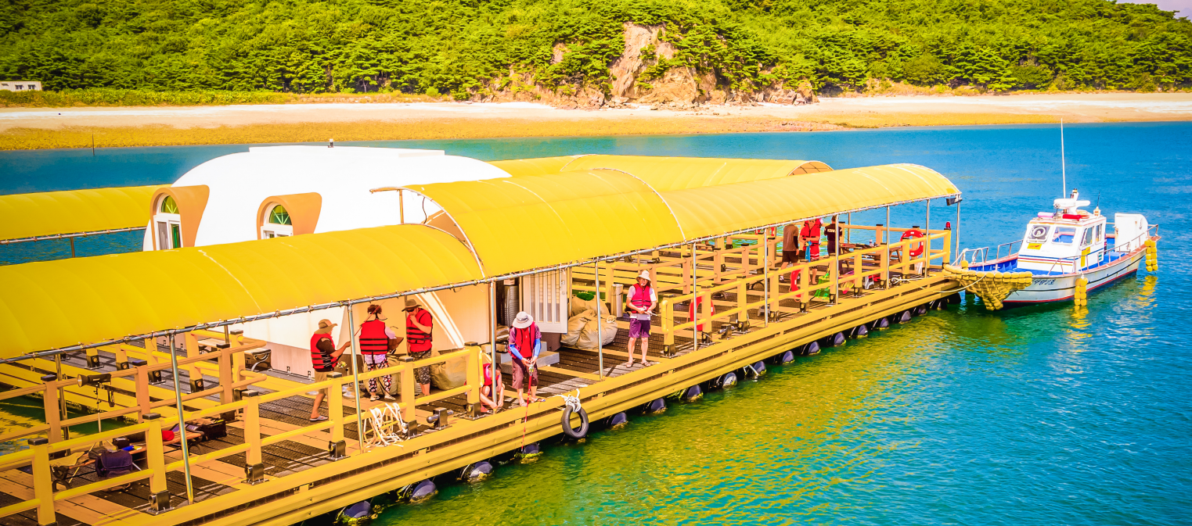
17:00-18:00 | Dinner
18:00-19:00 | From Gunsan to Incheon Airport
Day 5: 18 Oct (Friday)
Departure of the participants to PR China

